Subnetting Practice 1
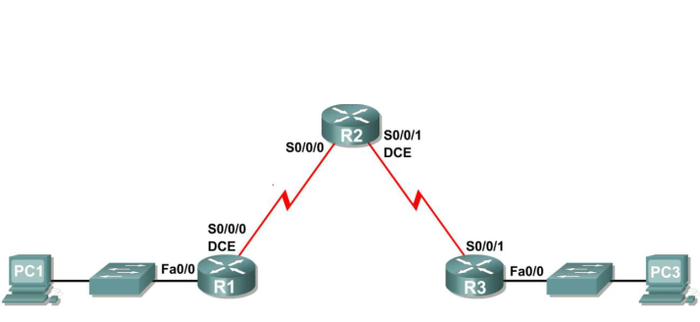

Original IP Address: 10.11.12.0
Original Subnet Mask: 255.255.255.0
Original Network Prefix: /24

- You have been given the above topology diagram and network address information. You have been asked to subnet the address space so that you can have the most number of hosts available as possible for each subnet. Answer the following questions:

How many subnets do you need? ____4____

How many bits do you need to borrow to create the subnets? __2_(2² =4)_____

How many usable host addresses per subnet are in the new scheme? ____62_(2⁶-2)___

What is the new network prefix? ___/26__(24+2)____

- Complete the subnetting exercise and fill in the below table.

Subnet | Network Address | First Useable Host | Last Useable Host | Broadcast Address
0 | 10.11.12.0 | 10.11.12.1 | 10.11.12.62 | 10.11.12.63
1 | 10.11.12.64 | 10.11.12.65 | 10.11.12.126 | 10.11.12.127
2 | 10.11.12.128 | 10.11.12.129 | 10.11.12.190 | 10.11.12.191
3 | 10.11.12.192 | 10.11.12.193 | 10.11.12.254 | 10.11.12.255

- It has come to your attention that it was short sighted to not provide for expansion of your network topology. You decide to re-do the subnetting exercise and this time allow for the possibility of having double the amount of current networks in your future network topology. Answer the questions and fill in the below table.

How many subnets do you need? _____8___

How many bits do you need to borrow to create the subnets? ____3____

How many usable host addresses per subnet are in the new scheme? ____30____

What is the new network prefix? ___/27_____

Subnet | Network Address | First Useable Host | Last Useable Host | Broadcast Address
0 | 10.11.12.0 | 10.11.12.1 | 10.11.12.30 | 10.11.12.31
1 | 10.11.12.32 | 10.11.12.33 | 10.11.12.62 | 10.11.12.63
2 | 10.11.12.64 | 10.11.12.65 | 10.11.12.94 | 10.11.12.95
3 | 10.11.12.96 | 10.11.12.97 | 10.11.12.126 | 10.11.12.127
4 | 10.11.12.128 | 10.11.12.129 | 10.11.12.158 | 10.11.12.159
5 | 10.11.12.160 | 10.11.12.161 | 10.11.12.190 | 10.11.12.191
6 | 10.11.12.192 | 10.11.12.193 | 10.11.12.222 | 10.11.12.223
7 | 10.11.12.224 | 10.11.12.225 | 10.11.12.254 | 10.11.12.255

- It has been decided that you will never have more than six hosts per subnet (including the router interfaces). You now have a policy of minimising wastage of IP host addresses. Re-do the subnetting exercise and fill in the below table.

How many subnets do you need? __32___(work out number of host bits needed first (3). Network bits is the remainder, 2⁵=32)

How many bits do you need to borrow to create the subnets? ____5____

How many usable host addresses per subnet are in the new scheme? ___6_(2³-2)____

What is the new network prefix? ___/29_____

Subnet | Network Address | First Useable Host | Last Useable Host | Broadcast Address
0 | 10.11.12.0 | 10.11.12.1 | 10.11.12.30 | 10.11.12.7
1 | 10.11.12.8 | 10.11.12.9 | 10.11.12.14 | 10.11.12.15
2 | 10.11.12.16 | 10.11.12.17 | 10.11.12.22 | 10.11.12.23
3 | 10.11.12.24 | 10.11.12.25 | 10.11.12.30 | 10.11.12.31
4 | 10.11.12.32 | 10.11.12.33 | 10.11.12.38 | 10.11.12.39
… | … | … | … | …
31 | 10.11.12.248 | 10.11.12.249 | 10.11.12.254 | 10.11.12.255

